Nepal College of Information Technology
Unit Test
Fall 2012
Program : BE IT Time : 2 hrs
Semester : (III) FM : 70
Subject : Electronic Circuits-I PM : 35

- Candidates are requested to give their answer as far as practicable in their own words.
- The figure in the margin indicates the full marks
- Attempt ALL question

1 a. Determine the overall input impedance , output impedance and voltage gain of emitter-Follower amplifier configuration with neat diagram. 8
b. Find overall voltage gain ( V_{L} / V_{S} ) in dB and show all values in its equivalent circuit. (Assume r_{e} = 25Ω, β = 100 and r_{c} = 10 KΩ) 7
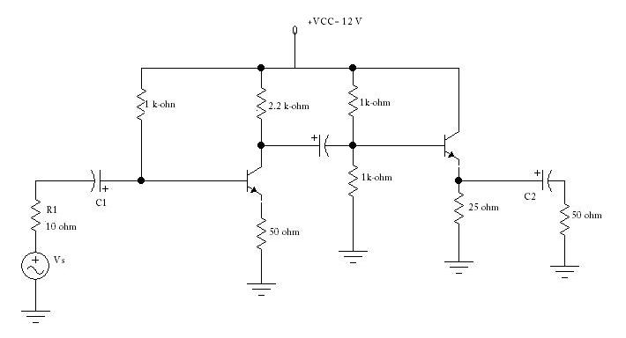

2 a. Darlington pair amplifier is practical example of which transistor configuration? Why is it called a super-beta transistor? 1+7
b. Describe overall effect of shunt capacitance on high frequency response with necessary diagram. 7
3 a. What is Miller effect? Describe Miller effect capacitance in detail with necessary diagram 2+6
b. what is distortion? Describe the types of distortion. 1+6
4 a. “Negative feedback reduces gain and improves SNR”. Justify. 4+4
b What is frequency response of an amplifier? Prove that power at cut-off frequencies is half the power at midband range. 3+4
5. Write short notes on (any two) 5*2 = 10
a. Multistage Amplifier
b. Miller Effect
c. Advantage of negative feedback.

